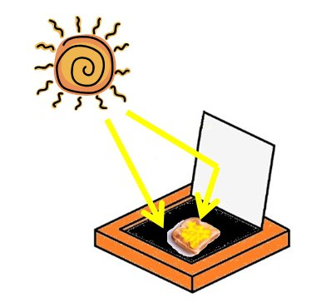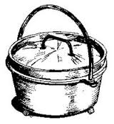C:\Users\Acer\AppData\Local\Microsoft\Windows\Temporary Internet Files\Content.IE5\NKV4GUHJ\MC900185680[1].wmf

In times of disaster or emergency, having a way to prepare hot meals for your family that does not require electricity is important. Plan a method you can use if you are not displaced from your home as well as a method you can use if you have to be evacuated from your home. Below are some examples:

**Fireplace** – one of the most primitive ways to cook food aside from cooking on a campfire. Although it was once THE way to prepare meals in the home, this method is unfamiliar to most of us today. If you have a fireplace and plan to use it in times of emergency be prepared with the proper utensils, cookware and ability to build the right kind of fire to cook on.

**Dutch Oven**- the dutch oven is a thick walled cast iron cooking pot with a tight fitting lid. They are well suited for long, slow cooking. Food is cooked inside the dutch oven pot by arranging hot charcoal briquettes on top and underneath the pot.

**Volcano Grill-** portablegrill that can use propane, charcoal, or wood as a fuel source. A dutch oven can be used on this grill. <http://www.volcanogrills.com/>

**Solar Oven**- oven box that utilizes the sun as fuel source for long, slow cooking. Any meal cooked in a conventional oven can also be cooked in a solar oven. You can find out more information and purchase a nice one at this link: <http://www.sunoven.com> , but you can also make your own. There are many designs available on-line.

**Rocket Stove-** an efficient cooking stove using small diameter wood fuel which is burned in a simple high-temperature combustion chamber containing a vertical chimney and a secondary air supply which ensures almost complete combustion prior to the flames reaching the cooking surface. Here are a few versions that you can make using your empty #10 cans:

<http://prepared-housewives.com/how-to-build-a-rocket-stove-and-impress-the-boys/> <http://www.instructables.com/id/How-to-make-a-Rocket-Stove-from-a-10-Can-and-4-So/>